**Steller’s Eider and Spectacled Eider Interaction Plan North Slope of Alaska and Yukon‐Kuskokwim Delta National Science Foundation, Arctic Sciences Division**

For Researchers and Contract Employees working on the Tundra

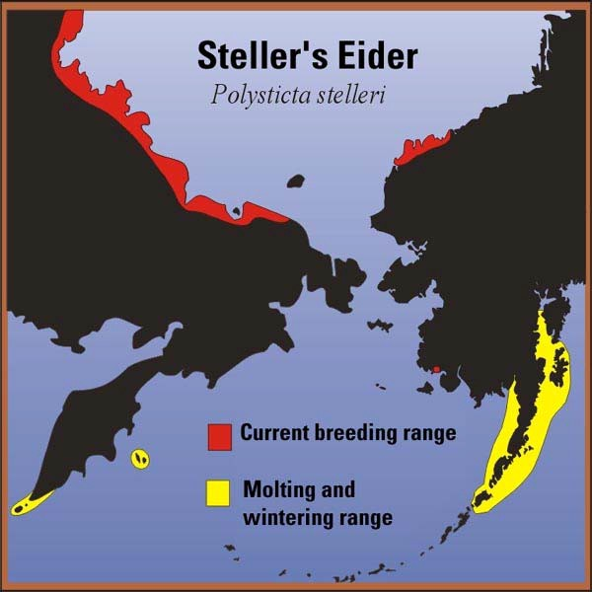[Steller’s eider (*Polysticta stelleri*)](https://www.fws.gov/species/stellers-eider-polysticta-stelleri) and [spectacled eider (*Somateria fischeri*)](https://www.fws.gov/species/spectacled-eider-somateria-fischeri) are two sea ducks that NSF researchers may encounter during field work. They are both listed as endangered species. NSF has developed this Interaction Plan to provide basic information about these species to guide you as you conduct your research. More information about both may be found at U.S. Fish and Wildlife Service’s [website](https://www.fws.gov/).

## USFWS Contact information:

Please notify USFWS as soon possible should you encounter Steller’s eider, spectacled eider, or nests of either species during your research or access to research sites. Report to USFWS at:

Neesha Stellrecht

Fish and Wildlife Biologist

U.S. Fish and Wildlife Service Fairbanks Fish and Wildlife Field Office 101 12th Avenue, Room 110

Fairbanks, AK 99701

Phone: (907) 456‐0297

Fax: (907) 456‐0208

e‐mail: [neesha_stellrecht@fws.gov](mailto:neesha_stellrecht@fws.gov)

# Steller’s Eider

Steller’s eider (*Polysticta stelleri*) is a small sea duck (43‐47 cm long or 17‐18.5 inches). In the U.S., their breeding range is limited to the arctic coastal plain and the Yukon‐Kuskokwim (Y‐K) Delta. Recently, nesting has been observed primarily between Wainwright and Prudhoe Bay, concentrated in the Barrow area.

Steller’s Eider Range Map (Source USFWS)

Steller’s eider feed in tundra lakes and ponds and nest in vegetation growing near pond edges.

Females primarily incubate eggs and the male remains near the nest. The birds typically may be encountered at nests (either laying, incubating, or brooding) between April and August.

Activity conducted on foot or from boats on small ponds within the nesting range could result in encounters with Steller’s eider. Researchers and contractors working in the Barrow area in particular should become familiar with identifying male (shown below in foreground in breeding plumage) and female Steller’s eider (shown behind the male) – see photograph next page.

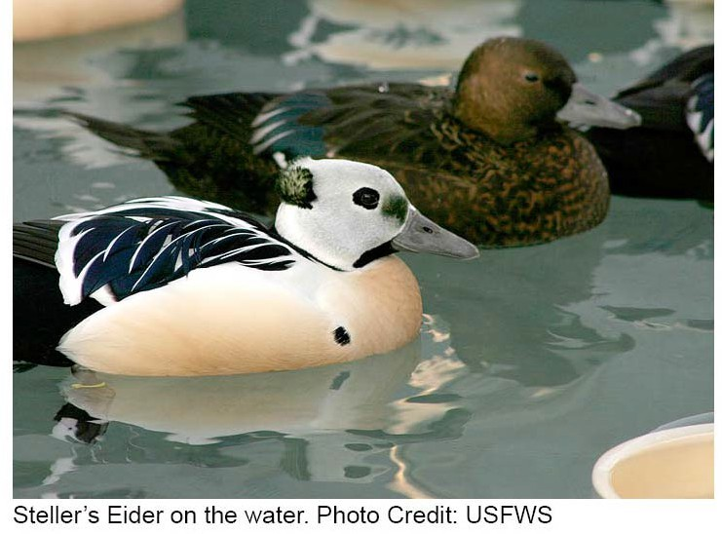

If you encounter a Steller’s eider in a potential nesting area (near the shore of small ponds or in drained lake basins) between April and August, do not approach the animal. Stop and scan the area for a potential nest. If you locate a nest, please note the location as precisely as possible and leave the area immediately in the same direction from which you came. Please avoid flushing the bird from the nest, which exposes the nest to predation, and avoid approaching the nest, which can leave a scent trail that can lead foxes to the nest.

If you encounter a Steller’s eider, please notify USFWS at the first opportunity through the contact information provided at the beginning of this document. Also, please report to USFWS the locations of any nests observed and any other observations regarding the species, particularly whether you saw one or both adults and whether any predators were nearby (e.g., foxes, jaegers, or snowy owls).

## Additional Information from USFWS

Steller’s eider is the smallest of the four eider species, averaging 43‐47 centimeters long (17‐18.5 inches). In the winter and spring (January through July), adult males are in breeding plumage with a black back, white shoulders, chestnut breast and belly, a white head with a greenish tuft, and small black eye patches. During the late summer and fall

(July through December), males are entirely mottled dark brown. Females and juveniles are mottled dark brown year‐round. Adults of both sexes have a blue patch with a white border on the upper wing, similar to a mallard.

Steller's eider breeds in northern Russia and northern and western Alaska. Biologists estimate that the world population of Steller's eider is around 220,000, with most nesting in Russia. The number of pairs nesting on Alaska's arctic coastal plain is very roughly estimated at 1,000.

Approximately 4,000 pairs of Steller's eider may have nested on the Yukon‐Kuskokwim Delta prior to the 1960's and the worldwide population of Steller's eider may have decreased by as much as 50% over the last 30 years. Most Steller's eider breeding in Alaska and Russia migrate south after breeding to molt along the coast of Alaska from Nunivak Island to Cold Bay, primarily in Izembek Lagoon, Nelson Lagoon, and near the Seal Islands. During their northward spring migration from wintering areas in Alaska, Steller's eider can be found in large flocks close to shore from northern Bristol Bay to Hooper Bay.

## Habitat and Habits

Steller's eider is a diving duck that spends most of the year in shallow, near‐shore marine waters.

Molting and wintering flocks congregate in protected lagoons and bays, as well as along rocky headlands and islets. They feed by diving and dabbling for molluscs and crustaceans in shallow water. In summer, they nest on coastal tundra adjacent to small ponds or within drained lake basins. During the breeding season they feed on aquatic insects and plants in freshwater ponds and streams.

## Reasons for Current Status

Causes of the decline world‐wide and in Alaska are not known. Lead poisoning, caused by ingesting spent lead shot during feeding, may have affected Steller's eider on the Yukon‐Kuskokwim Delta.

Predation by ravens, large gulls, and foxes on the

breeding grounds may be increasing in areas where populations of these predators are enhanced by the year‐round food and shelter provided by human activities and garbage dumps. Hunting also poses a threat to Steller's eider. Disturbance and loss of nesting habitat due to oil and gas development may have occurred in Siberia.

Increased shipping traffic poses the risk of oil spills and disturbance of feeding flocks in marine waters. Other possible causes of the decline include marine contaminants and changes in the Bering Sea ecosystem affecting food availability, but there is very little information about the effects of these factors on Steller's eider.

# Spectacled Eider

The spectacled eider (*Somateria fischeri*) is a large sea duck (50.8‐55.9 cm long or 20‐22 inches).

Nesting in the United States occurs along the northern coast of Alaska and in the coastal portions of the Y‐K Delta.

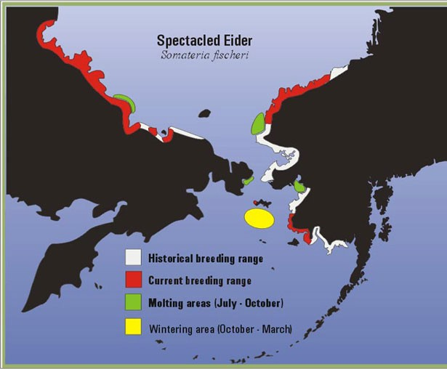

Spectacled Eider Range Map (Source USFWS)

Spectacled eider feed in wet tundra lakes, ponds, and wetlands and nest in vegetation growing near pond edges. Females incubate the eggs and raise the brood. Males do leave the nesting grounds shortly after eggs are laid. Males may be encountered on the nesting grounds from April

through June and females may be encountered on the nesting grounds from April through early September. The females may be encountered with young from late July through early September.

Researchers and contractors working along the northern coast of Alaska or in the Y‐K Delta should become familiar with identifying male (shown below in foreground in breeding plumage) and female spectacled eider (shown behind the male).

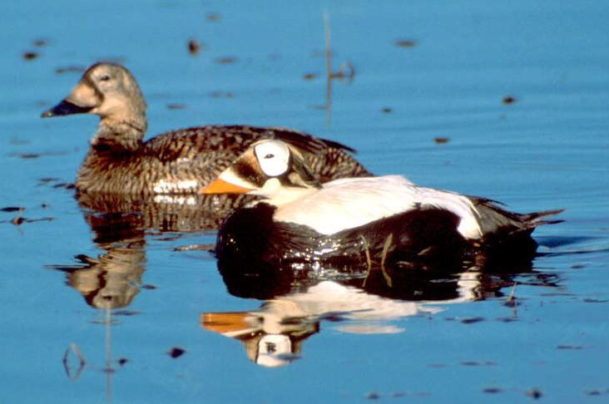

Spectacled Eider on Water. Photo Credit: USFWS

If you encounter a spectacled eider in a potential nesting area (near the shore of small ponds or in drained lake basins) between April and early September, do not approach the animal. Stop and scan the area for a potential nest. If you locate a nest, please note the location as precisely as possible and leave the area immediately in the same direction from which you came. Please avoid flushing the bird from the nest, which exposes the nest to predation, and avoid approaching the nest, which can leave a scent trail that can lead foxes to the nest.

If you encounter a spectacled eider, please notify USFWS at the first opportunity through the contact information provided at the beginning of this document. Also, please report to USFWS the locations of any nests observed and any other observations regarding the species, particularly whether you saw one or both adults and whether

any predators were nearby (e.g., foxes, jaegers, or snowy owls).

## Additional Information from USFWS

The spectacled eider is a large sea duck, 51‐56 cm long (20‐22 inches). In winter and spring, adult males are in breeding plumage with a black chest, white back, and pale green head with a long sloping forehead and white spectacle‐like patches bordered in black around the eyes. During the late summer and fall, males are entirely mottled brown. Females and juveniles are mottled brown year round with pale brown eye patches.

Spectacled eiders breed in northern Russia and northern and western Alaska. There are three primary nesting areas: the central coast of the Y‐K Delta, the arctic coastal plain of Alaska, and the arctic coastal plain of Russia.

Biologists estimate that the world population of spectacled eiders is around 370,000, with most nesting in Russia. The number of pairs nesting on Alaska's arctic coastal plain is estimated at 5,000 – 6,000. Approximately the same number of pairs of spectacled eider nest on the Y‐K Delta, down from an estimated 50,000 pairs in the 1960s. After breeding, spectacled eider migrate to molting areas, with males migrating to molting areas by late June and females migrating with their young by early September. Important late summer and fall molting areas occur in eastern Norton Sound and Ledyard Bay in Alaska, and in Mechigmenskiy Bay and an area offshore between the Kolyma and Indigirka River Deltas in Russia. Winter flocks of spectacled eider have been observed in openings in sea ice in the Bering Sea between St. Lawrence and St. Matthew islands.

## Habitat and Habits

The spectacled eider is a diving duck that spends most of the year in marine waters, feeding primarily on bottom‐dwelling mollusks and crustaceans. In spring, breeding pairs move to nesting areas on wet coastal tundra and establish

nests near shallow ponds or lakes. During the spring, spectacled eider feed by dabbling in ponds and wetlands, eating aquatic insects, crustaceans, and vegetation. Soon after eggs are laid (usually by the end of June), males leave the nesting grounds for offshore molting areas. Females whose nests fail leave the nesting area to molt at sea by mid‐ August. Breeding females and their young remain on the nesting grounds until early September.

## Reasons for Current Status

Causes of the decline of the spectacled eider are not well understood. Shifts in the Bering Sea ecosystem, including weather patterns and complex changes in fish and invertebrate populations, may be affecting food availability and survival of spectacled eider during the 8‐10 month nonbreeding period. On breeding grounds and migration corridors, where threats can be addressed more feasibly, lead poisoning, predation, and illegal harvest have been identified as the primary constraints to recovery. Arctic foxes, ravens, and large gulls are the prime nest predators of spectacled eider and may be increasing in areas where year‐round food and shelter is provided by human activities. There is no legal hunting of spectacled eider, but is it suspected that hundreds of these birds are illegally taken each year. Lead poisoning is an indirect result of hunting, where eider ingest spent pellets incidental to feeding activity.